
NAME:
Ahmad Raza (53302)
Atia Rahat (57325)
Zain Zaheer(53812)

PROGRAM:
BSSE-6

COURSE:
SPM

PROJECT:
Sales Point

DOCUMENT:
Lab 5

SUBMITTED TO:
Sir Waqar Mehmood

Dashboard: 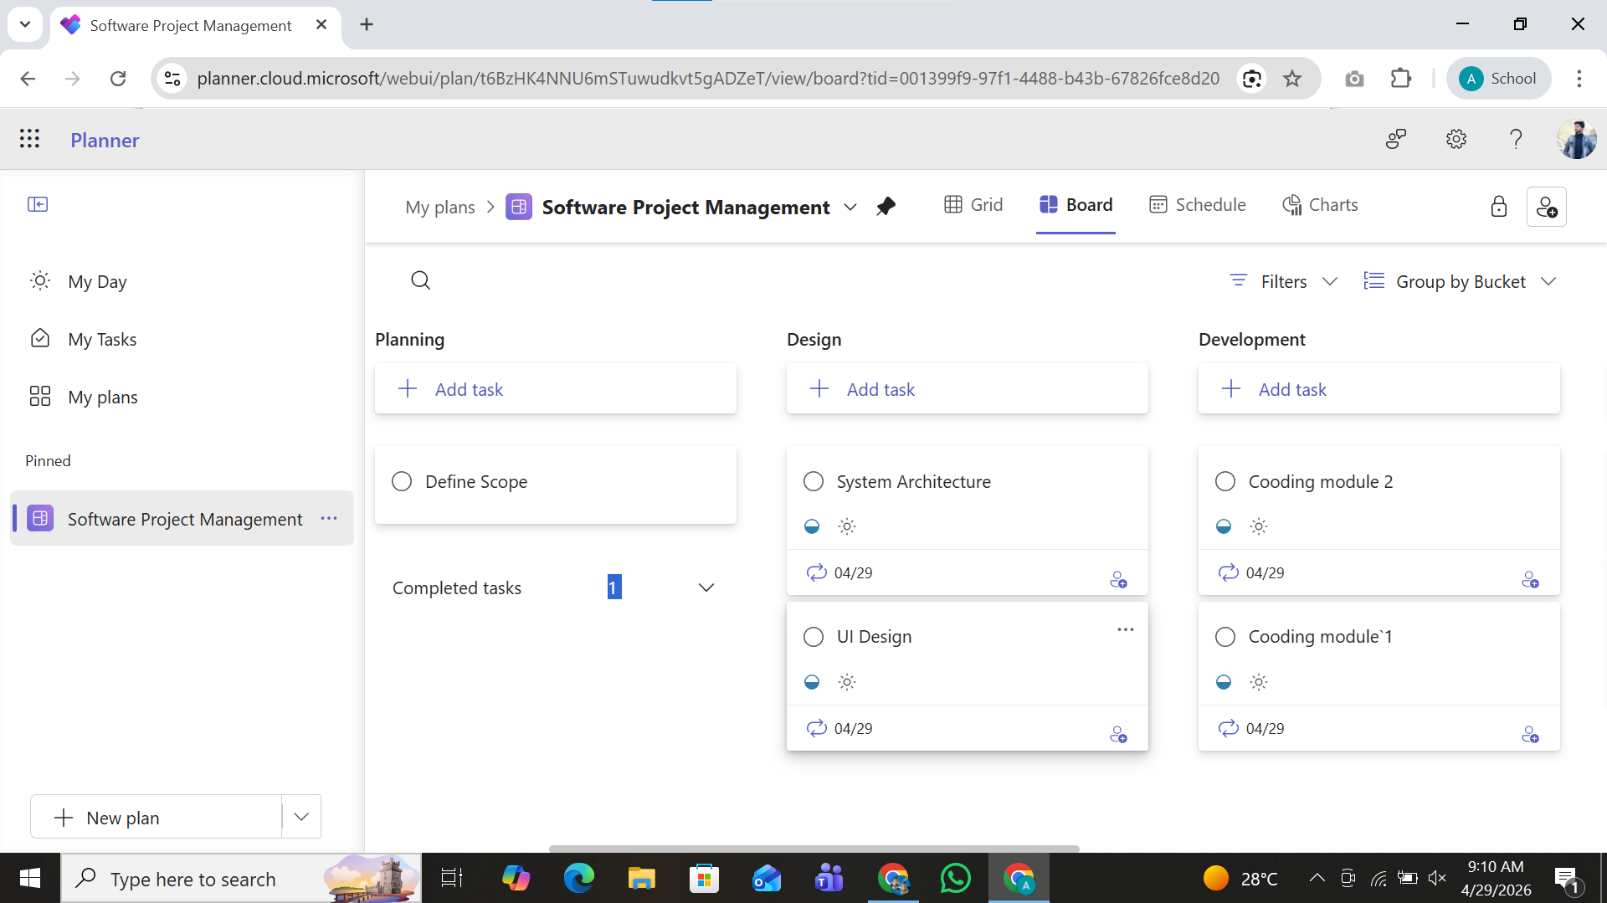

Chart board :
